**ASSIGNMENT -3**

**BSAN 775: INTRODUCTION TO BUSINESS ANALYTICS**

**Monday 7.00 PM**

**Dr. Justin Keeler**

**April 27, 2023**

**Group 5:**

**Narayanam Naga Vamsi Sandeep**

**Kevin Pwka**

**Rana Fawaz**

**Ahmed Elsayed**

**Akash Pandla**

**Cliff Wullschleger**

**DATA SET:**

<https://www.kaggle.com/datasets/laibaanwer/superstore-sales-dataset>

**PROBLEM:**

The problem we will focus on is inventory management in a retail store. This is a common problem that many retailers face, as they need to balance having enough inventory to meet customer demand while avoiding overstocking and wasting resources on excess inventory.

**OBJECTIVE:**

The objective is to predict the minimum quantity of different types of Apple headsets needs to be sold to get the optimal profit by satisfying all the constraints.

**DECISION VARIABLES:**

The decision variables are different types of apple headsets - Apple Headset Full size, Apple Headset VoIP, Apple Headset with caller ID, Apple Headset cordless.

**Profit** – The profit that we gain by selling the products. Here, we considered the profit of each item based on the average profit achieved by selling the product.

**Quantity** – Each item requires a certain number of products to be purchased.

**CONSTRAINTS:**

In order to identify the optimal solution to a problem, some restrictions or requirements must be met those restrictions or requirements are called as constraints.

* Count: Sum of all the quantity should not be greater than 15.

Total = q1 + q2 + q3+ q4.

* Minimum quantity of Apple full size headset should not be greater than or equal to3
* Minimum quantity of Apple headset with caller id should not be greater than or equal to2
* Minimum quantity of Apple headset VoIP should not be greater than or equal to2
* Minimum quantity of Apple cordless headset should not be greater than or equal to 2

**OBJECTIVE FUNCTION:**

The objective function for this problem would be to minimize the total cost of inventory which includes both the cost of holding inventory and the cost of stock outs. Determining the minimal quantity to be produced in order to get the minimum profits by setting the profit as a constant for each decision variable.

To calculate Objective function, consider Apple Headset, with Caller ID as Q1 and their profit and quantity as P1 and q1 Apple Headset Full Size as Q2 and their profit and quantity as P2 and q2, Apple Headset VoIP as Q3 and their profit and quantity as P3 and q3, Apple Headset Cordless as Q4 and their profit and quantity as P4 and q4.

Objective function is taken as the sum product of Quantity and profit

Objective function = q1*p1 + q2*p2 + q3*p3 + q4*p4.

**CHANGING VARIABLES:**

Quantity is being used as a changing variable in this Dataset and calculated using excel in solver.

**LINEAR PROGRAMMING:**

Linear programming is used to find optimal solution of the decision variables by satisfying all the constraints mathematically.

Here, we are using solver which is present in Excel tool to predict optimal solution to find minimum quantity of products needs to be sold

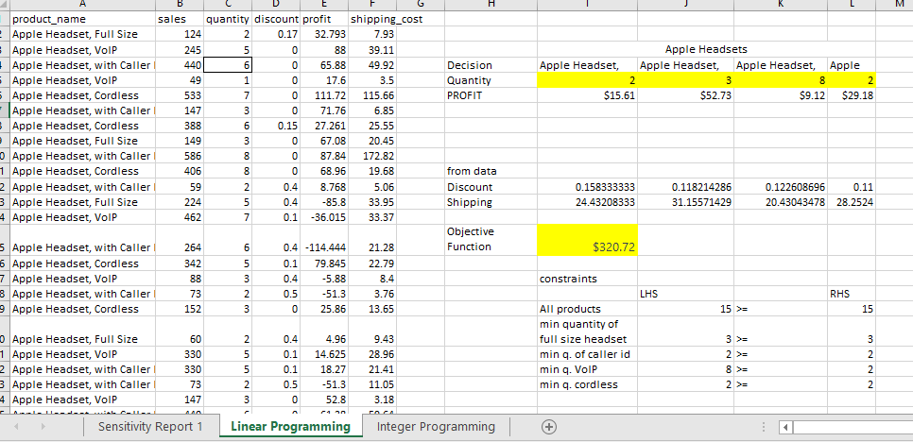

The Results obtained from linear programming are:

Minimum number of Apple Headset, with Caller ID to be sold is 2, Minimum number of Apple Headset Full Size to be sold is 3, Minimum number of Apple Headset VoIP is 8 and Minimum number of Apple Headset Cordless is 2 to achieve the profit by satisfying all the constraints. The Minimum profit that can be achieved is $320.72 and it is the objective function.

**SENSITIVITY ANALYSIS:**

In Linear programming sensitive analysis is used to calculate the optimal solution if there is any change in decision variables.

**For Decision variables:**

Lower limit = Objective Coefficient – Allowable Decrease

Upper Limit = Objective Coefficient – Allowable Increase

**For Constraints:**

Lower limit = Constraint RH side - Allowable Decrease

Upper Limit = Constraint RH side - Allowable Increase

If the change in profits is between the lower and upper limits then there will not be any change in quantity else, the quantity value changes.

Slack = Constraint RH side – Final value

Surplus = Constraint RH side + Final value

If the Difference between Constraint RH side – Final value is zero then it is called Binding else, Non-Binding.

Shadow price is used to calculate the objective function if there is any change in Decision variables. In our case, if there is 3 unit’s addition profit to a decision variables then objective function can be calculated using shadow price (3* shadow price) and this value is added to objective function.

**INTEGER PROGRAMMING:**

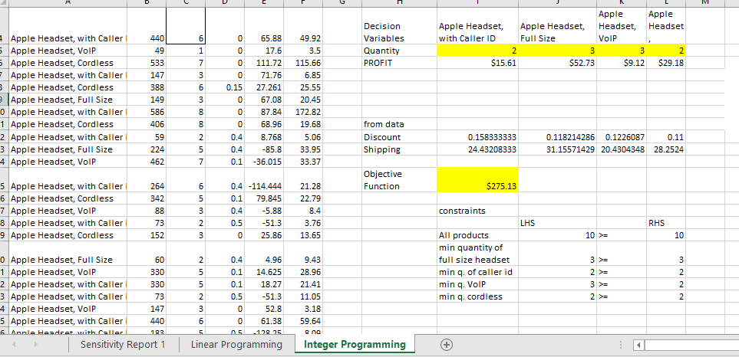

The constraints decision variables and constraints are same as Linear programming but the only difference is we are also taking changing variables as an Integer constraint.

The Results obtained from Integer programming are:

Minimum number of Apple Headset, with Caller ID to be sold is 2, Minimum number of Apple Headset Full Size to be sold is 3, Minimum number of Apple Headset VoIP is 3 and Minimum number of Apple Headset Cordless is 2 to achieve the profit by satisfying all the constraints. The Minimum profit that can be achieved is $275.13 and it is the objective function.

**ROLE OF CHATGPT:**

We took the head part of the dataset and copied in ChatGpt and asked few questions on decision variables, constraints and objective function to solve linear programming using solver in excel? Then, it showed us the directions to solve Linear programming. We also asked the difference between Linear Programming and Integer programming and it explained us. We had an amazing experience to use chat and awestruck by its solutions.

**CONCLUSION:**

The only difference between Integer programming and Linear programming is how we are considering the variables. In case of Linear Programming we are considering real (continuous values) which includes fractions and in Integer programming we are considering integer values (Whole number).

In Real world scenario, the decision to choose between linear programming and Integer programming is how we want the variables to be taken. If we want to calculate and consider even the fractional values, we choose linear programming or if we want variables to get round off then we choose Integer programming.